***IIBEW***

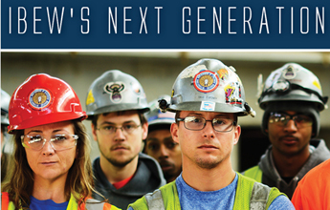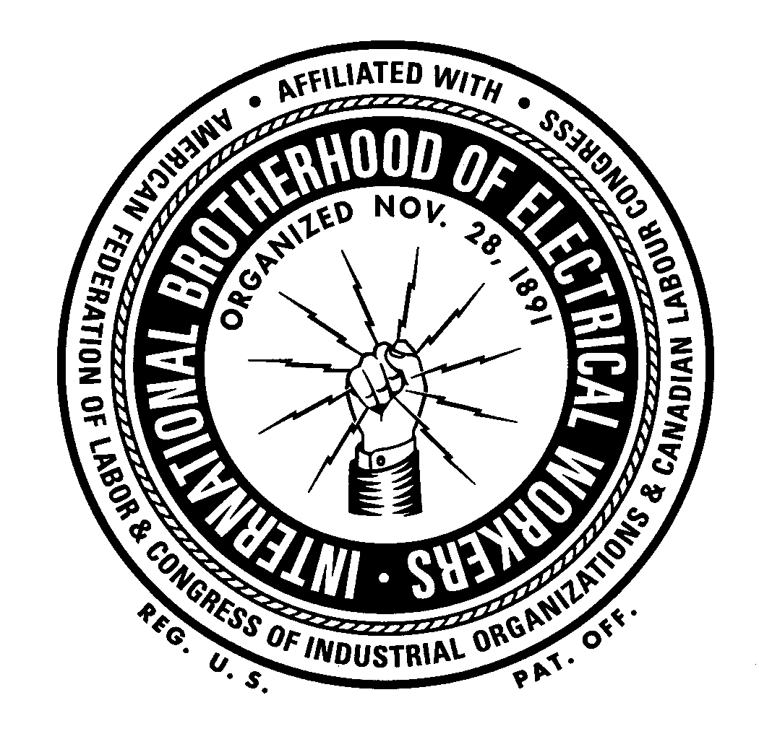

# ***LOCAL 949***

# ***NEWSLETTER***

Winter 2013 Volume 12 Issue 3

Wanted – the next generation!

America’s unions need active young members and they need them now. Young workers have the most to lose if they don’t get active now. So, who is reaching out to get them involved?

Within the IBEW, the **RENEW** effort was introduced at the 2011 38th International Convention.

RENEW stands for “Reach Out and Energize Next-gen Electrical Workers.” Its mission: to inspire the next generation of IBEW workers to become active in their local union by focusing on issues important to young workers.

***Its mission: to inspire the next generation of IBEW workers to become active in their local union by focusing on issues important to young workers.***

RENEW has provided young IBEW members a space to network and organize in order to advance their interests and help bridge the gap between generations in order to strengthen the union as a whole. Local groups have sponsored educational meetings, social outings, and set-up Facebook groups to facilitate communications. But one-on-one conversations, between members, at local union meetings, are the basic building steps for success. Young workers need to be asked what their needs and goals are and asked to please serve.

**HAPPY HOLIDAYS**

The first RENEW Conference was held this past September in Washington, D.C.. Over 100 young members not only attended but conducted the conference as well.

On a broader level, the AFL-CIO’s young workers program is refereed to as “NextUp.” This program was introduced in 2011 by Secretary Treasurer **Elizabeth Shuler** (who is a member in good standing in the IBEW). Other unions also have programs to invite young workers to get active.

If you are a young worker (broadly characterized as ages 18-35) and want to get involved, the fastest way is to introduce yourself to your local officers and tell them you want to pursue RENEW. They can send you in the right direction.

And it is the right direction; for you, for your family and for the future of the union movement.

It’s basic: United we stand, divided we fall. Stand up for you.



**BE A GOOD UNION MEMBER**

KNOW YOUR CONTRACT■ATTEND YOUR UNIT MEETINGS■STAY INFORMED■

PRACTICE SOLIDARITY■BE AN EDUCATED VOTER■BE AS FINANCIALLY PREPARED AS POSSIBLE■BE READY TO VOLUNTEER IF YOUR UNION NEEDS YOU■

WORK SAFELY■WORK HONESTLY ■HELP THOSE LESS FORUNATE

**BE A GOOD UNION MEMBER**

KNOW YOUR CONTRACT■ATTEND YOUR UNIT MEETINGS■STAY INFORMED■

PRACTICE SOLIDARITY■BE AN EDUCATED VOTER■BE AS FINANCIALLY PREPARED AS POSSIBLE■BE READY TO VOLUNTEER IF YOUR UNION NEEDS YOU■

WORK SAFELY■WORK HONESTLY ■HELP THOSE LESS FORTUNATE

IT’S A RODEO!

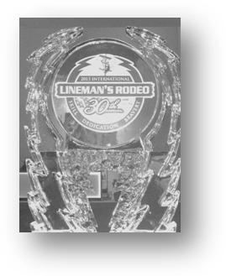

This year, on October 19, the 30th Annual International Rodeo had over 200 teams and 250 apprentices from every state in the union as well as parts of Canada participating. The Annual Lineman’s Rodeo, Kansas City Rodeo began in September, 1984 with only twelve participating teams from Kansas and Missouri.

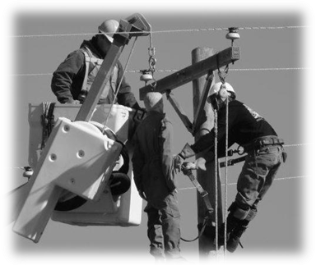

Contestants converged on the fields at the Agricultural Hall of Fame outside Bonner Springs, Kansas on a chilly but beautiful Saturday morning. Apprentices and Journeymen alike competed in a wide variety of events including: hurtman rescue, pole climbing, apprentice written tests and two mystery events. Local 949 was represented by Apprentice **Ryan Gruber** and Journeyman **Mark Posey**, both from Alliant Energy.

Many families of the participants accompany their lineman to watch and cheer them on. The Rodeo has a carnival like atmosphere including food and souvenir vendors and rides in bucket trucks.

If the opportunity to attend the Lineman’s Rodeo comes along, I urge you to attend. It was truly an impressive sight.

*Elain Tiedt, 949 Office Manager*

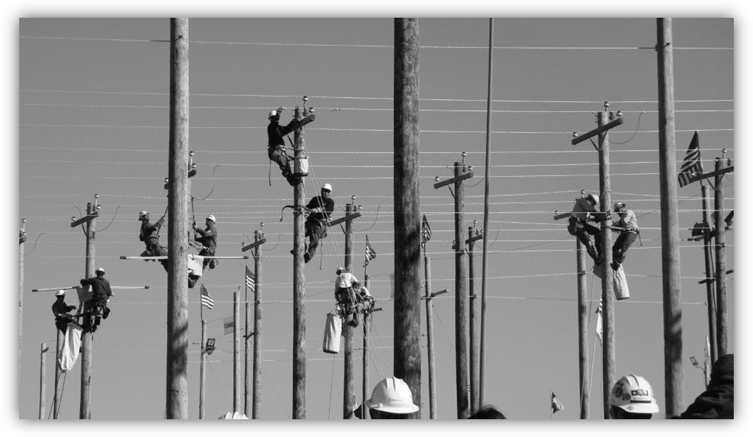

Any organizing leads are appreciated and should be sent to

The attention of

Business Rep **Mike O’Connor**

At moconnor@ibewlocal949.org

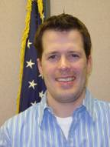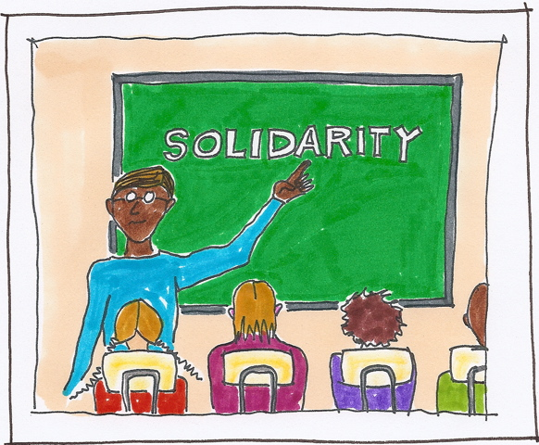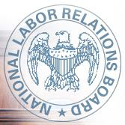

DOOR’S OPEN

The U.S. Senate on July 30 confirmed five nominees to the National Labor Relations Board, bringing to an end a stalemate that had threatened to shut down the board.

The Senate acted on separate 54-44votes to confirm Democrats **Nancy Schiffer**, a former AFL-CIO associate general counsel, and **Kent Hirozawa**, chief lawyer for the board’s Chairman **Mark Gaston Pearce**. Two Republican seats, vacant since December were confirmed by voice vote. They were **Phillip Miscimarra**, a former labor and employment lawyer from Chicago and **Harry I. Johnson III**, a lawyer in California. Mark Pearce was tapped for a second term by 59-38. **Richard Griffin** was approved as general counsel in a vote taken in November.

*For the first time since President Obama took* *office, all five seats to the labor board will be filled*. The votes to fill the seats “will revitalize our commitment to protect the rights of American employers and employees,” Pearce said in a statement after the vote.

The confirmation came as part of a compromise reached earlier between Senate Democrats and Republicans to approve numerous judicial and administration nominees. The board has been unable to function since December 2012 due to lack of members.

Dues Increase from the International Office

Effective January 1, 2014, there will be an increase of two dollars ($2.00) in the per capita that is paid to the General Fund, and therefore, the rate for all members will increase from $15 to $17. This increase was approved at the 38th IBEW International Convention in 2011.

Power plants are monuments to commerce and our way of life. Check out how the IBEW electricians from Alabama Local 136 did an outstanding job on the retrofit of Plant Miller. Check

it out at www.ibewhourpower.com

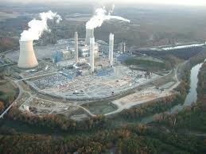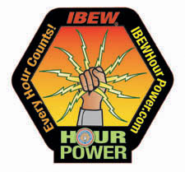

Hooray for…

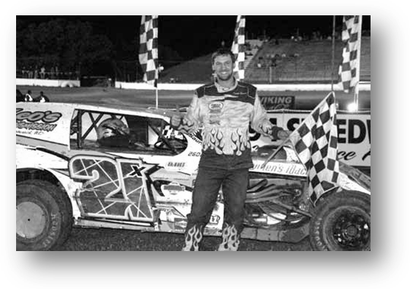

…Otter Tail Power’s (Fergus Falls, MN) **Travis Saurer** for another successful season of dirt track racing. Saurer is the WISSOTA 2013 Modified Point Champion

.

We Are Family-2013 Sixth District Progress Meeting and Women’s Conference.

Attending the IBEW Sixth District Progress Meeting and Women’s Conference was **Cy Grover**, Otter Tail Power Company, Fergus Falls, MN. The meeting was held in Rochester, MN. on September 17-19, 2013.

“We are family” was a representational tree which showed the IBEW as being the trunk, organizing as the roots, and the various divisions of the IBEW as the branches: Manufacturing, Railroad, Utility, Government employees, Broadcasting and Telecommunications, and Construction and Maintenance. “It was a powerful image showing organizing as the roots, because that is what the union builds on,” Grover explained.

Among the speakers were **Shar Knutson**, Minnesota AFL-CIO President and **Elizabeth Shuler**, Secretary-Treasurer with the AFL-CIO. Unexpected speakers included Governor **Mark Dayton** and **Erin Murphy**, DFL Majority Leader of the Minnesota State Senate. Grover was thrilled because, “it’s usually the other way around, someone expected, doesn’t show up. This was fun!”

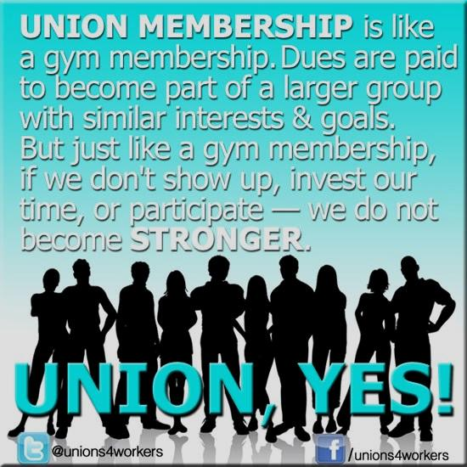

Grover had been invited to share a “Herstory” at the conference. “My story was simple because, after all, I am just the janitor,” joked Grover. Grover told the audience that she felt the IBEW had given her a good future when she became an IBEW member—good pay, good benefits and good security.

Then, Grover explained that now that she was retiring, 26 years later, that the Union had again

seen to it that she had a good future- a pension, health benefits and good security. “The IBEW gave me everything I needed to succeed and be secure,” she said. “In turn, I tried to be the best employee and the best union member that I could be.” The message resonated with the group because that’s exactly what being a union member all is about.

Grover would like to thank the Local 949 Executive Board for the experience, “I guess that will be my last conference and I am so very grateful that I got to go to a few. IBEW conferences are inspiring and top-notch!”

HICKORY TECH IS NOW ENVENTIS

949 members at Hickory Tech can now say they work at Enventis.

Providing voice, internet, and data communications across Minnesota, Iowa, South and North Dakota, and Wisconsin, the new name reflects the unifying of service under one name. Enventis started out as Mankato Citizen’s Telephone Company in 1898.

Enventis employee **Anna Brush** is Recording Secretary for Local 949.

*Shop Small…Shop Local*

*Keep some of that spending money in*

*your community. Mr. Walton has plenty.*

*SHOP SMART—BUY AMERICAN!!*

**2014 Schedule for Local 949 Board Meeting**

Meetings are held on the 3rd Saturday of each month, starting at 10:00 AM at the Hall. All members welcome. See you there!

January 18 February 15 March 15

April 19 May 17 June 21

July 19 August 16 September 20

October 18 November 15 December 20

**STILL SERVING OUR COUNTRY**

**BRADLEY BERGEMAN/ALLIANT ENERGY**

**JAKE MATZ/INTEK**

**JASON PODRITZ/INTEK**

*Shop American*

*Did you know that Hershey’s POT O’GOLD chocolates are made in Mexico?*

*Russell Stover Chocolates are Union Made in America!!!*

*SHOP SMART—READ THE LABELS!!*

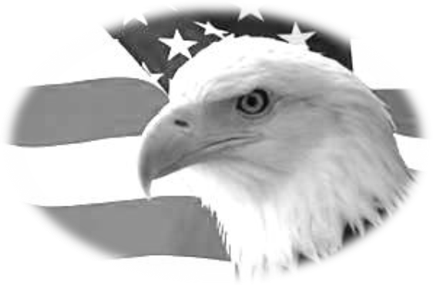

**UNION PLUS HAS PROGRAMS TO HELP YOU MANAGE INSURANCE COSTS FOR EVERYONE IN YOUR FAMILY, EVEN FIDO.**

**UNION PLUS OFFERS AUTO INSURANCE THROUGH 21ST CENTURY**

**UNION PLUS OFFERS LIFE INSURANCE THROUGH THE HARTFORD**

**UNION PLUS OFFERS $2,000 FREE ACCIDENTIAL LIFE INSURANCE**

**UNION PLUS OFFERS RETIREE HEALTH INSURANCE THROUGH UNITED AMERICAN INSURNACE COMPANY**

**UNION PLUS OFFERS PET INSURANCE FOR $17.95 PER MONTH**

**IN ADDITION, UNION PLUS OFFERS ASSISTANCE PROGRAMS TO HELP WITH:**

☺JOB LOSS



☺EDUCATION COSTS

*UNION PLUS HAS INSURANCE FOR YOU*

☺STRIKE BENEFITS

☺ JOB DISABILITY

☺LARGE HOSPITAL BILLS NOT COVERED BY INSURANCE

☺CREDIT AND BUDGET COUNSELING

☺DISASTER RELIEF FUND

**THESE BENEFITS INCLUDE GRANT MONEY THAT DOES NOT NEED TO BE REPAID FOR QUALIFIED MEMBERS OF UNION PRIVILEDGE**.

CHECK OUT THE NEW COUPON CENTER, THE NEW PRIVILEGE CARD THAT OFFERS 1.5% CASH BACK ON PURCHASES AND THE WHOLE LIST OF OTHER BENEFITS FOR UNION MEMBERS.

WWW.UNIONPLUS.ORG

# Weingarten Rights

If this discussion could in any way lead to my being disciplined or terminated or have any effect on my personal working conditions, I respectfully request that my union representative, officer, or steward be present at this meeting. Without union representation, I choose not to participate in this discussion.

🙑

**Call the Hall**

Burnsville Office: 12908 Nicollet Ave S.

Burnsville, MN 55337-3598

Phone 1-952-890-8484 or

1-800-833-0949.

BARTZ, Rick, Business Rep. ext. 106

BREKKE, Sharon, Dues Processing ext. 103

KAUFMAN, Mark, Business Rep. ext. 107

INGALLS, Todd.. ext. 109

OAKES, RICK, Business Mgr.. ext. 104

O’CONNOR, Mike, Business Rep ext. 105

SOWER, Katie ext. 102

THOMFORDE, Gary, Business Rep. ext. 108

TIEDT, Elain, Office Mgr. ext. 101

**E-mail: first name initial last** **name@ibewlocal949.org**

Example: roakes@ibewlocal949.org

Address change? Call the Hall and the International or use websites. THANKS!

www.ibewlocal949.org

keeping in touch with

our members



#### Of interest:

Local 949 meeting is the third Saturday of each month at the Burnsville Office at 10:00 a.m.

#### Find your legislative representatives:

www.house.gov

www.senate.gov

#### Support Unionism

www.ibew.org

www.aflcio.org

www.shopunionmade.com

*Comments welcomed at the Burnsville address or cy43@charter.net*

✂---------------------------------------------------------------------------------------------------------------------

# Check This Out:

Do you shop at a wholesale box store like Sam’s Club?

Check out shopping at **Costco**. Though only about 18% of Costco’s total workforce is unionized, union representation creates a ripple effect and helps determine labor standards in all stores. Not only do they pay their employees more, the benefits are very good.

Interestingly, their CEO only takes 10 times the pay of his typical employee, compared to the guy at Wal-Mart who takes home 531 times the pay of a typical employee (duh, that’s $350,000 vs. $5.3 million). While you’re there, look for products Made in America.

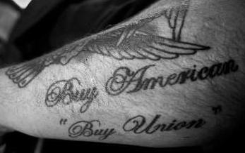

From our History:

The right to strike is an essential part of collective bargaining in our democratic society. Without the real possibility of a strike, there is little incentive for management to negotiate a fair settlement with labor.

Coretta Scott King

I come from a very dirty business. The enemy was the *collective spirit*. I got hold of that spirit while it was still a seedling. I poisoned it, choked it, bludgeoned it if I had to, anything to be sure it would never blossom into a united work force.

Martin J. Levitt,

Professional union buster

Note: No Fall issue of the newsletter was printed.

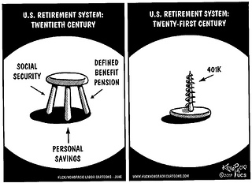

Non-Profit Org.

U.S. Postage Paid

Burnsville MN

Permit No. 202

******************************************************************************************

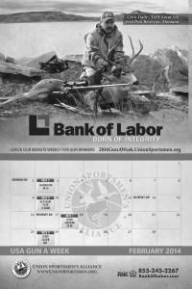

52 Chances to Win

**Purchase of the Union Sportsman Alliance’s (USA) 2014 Gun-A-Week** calendar, brings a chance each week to win a high-quality shotgun, rifle or handgun, including Remington firearms which are proudly made by members of Mine Workers Local 717.

That's 52 chances to win a gun for just $30 and your contribution helps support the USA's conservation efforts. The calendar features great photos of union members and their families in the great outdoors. This just may be the best Christmas present for someone in your family or for a friend.

To order, visit www.unionsportsmen.org and click on *calendars* in the top right-hand corner.

