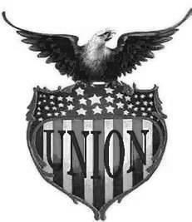
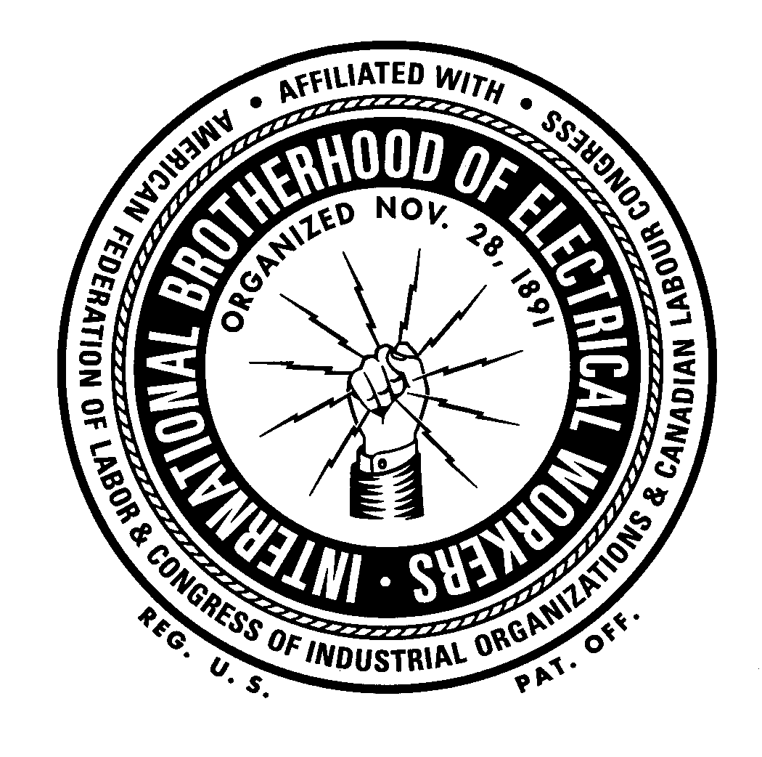

IBEW

LOCAL 949

NEWSLETTER
Summer 2012 Volume 11 Issue 2



From the desk of Rick Oakes…

Dear Brothers and Sisters:

By this time, we are all tired of listening to campaign ads. It seems they are assaulting us from all directions; television, radio, e-mails, flyers, signs in our neighbors’ yards. Some of them provide us with admittedly biased information, while others seem to be simply mud slinging. However you view these ads, it is important to remember that if elected, these are the people who run our government and write our laws for the length of their terms; the laws that impact our lives at home, school and work every day.
Under George W. Bush’s Republican administration, labor organizations came under attack. The National Labor Relations Board (NLRB) went from a “Labor Relations” function to a “Labor Policing” function. Government mandated record keeping requirements for local unions more than tripled under that administration, but without any such requirements for corporations. The more politically active Local Unions were targeted with Department of Labor audits. Given Mr. Romney’s well publicized views on unions, it is my expectation that millions, if not billions, of dollars will be spent on attempting to finish the job of destroying the labor movement in this nation that President Bush started.
Mitt Romney has been very outspoken about his views on unions. He has supported efforts to restrict collective bargaining in Ohio and has stated that he would encourage more states to adopt right-to-work laws and he proudly proclaimed that he has “taken on union bosses before. I’m happy to take them on again.” Let’s let him know that it’s not just “union bosses” he’s taking on in this election, but the millions of union workers and their families throughout this entire nation.
Mr. Romney earned his “street cred” by outsourcing American jobs as CEO of Bain Capital, encouraging other companies to ship even more jobs overseas and destroying American companies by forcing them to close plants, lay off workers and eliminate pensions and health care.
As your workplace representative, IBEW Local Union 949’s one and only focus in the political arena is on candidates who support workers and their families. While no single issue can or should be used to make such an important decision, we must support those candidates who support us. I do not presume to tell you how to vote. However, as your Business Manager, I urge you to support Labor endorsed candidates in your state and districts. It’s protecting your livelihood that I’m talking about.
As Dr. Martin Luther King, Jr. said when speaking to the AFL-CIO on December 11, 1961, “History is a great teacher. Now everyone knows that the labor movement did not diminish the strength of the nation but enlarged it. By raising the living standards of millions, labor miraculously created a market for industry and lifted the whole nation to undreamed of levels of production. Those who attack labor forget these simple truths, but history remembers them.”
However you choose to vote, I strongly urge you to exercise your constitutional right and duty as an American citizen by casting your vote in this year’s elections.
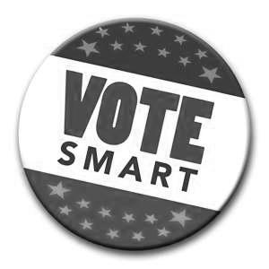
Fraternally,
Rick Oakes
Business Manager/Financial Secretary

NLRB-Held Captive Again

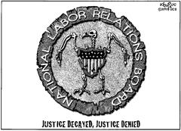
U.S. District Judge James Boasberg has struck down the National Labor Relations Board latest ruling of April 30, 2012. The new rule would have streamlined the union election process and upheld the right of employees to hold a secret vote in a timely manner.
The Chamber of Commerce and the anti-union Coalition for a Democratic Workplace filed lawsuits against the board over the changes but the ruling came about, not because the judge disagreed with the merits of the rule, but because it was made when there were only 2 sitting members on the board. Remember how the Republicans have stalled any of President Obama’s appointees?
Even the US Senate had rejected Republican efforts to overturn the changes with an amendment that would have curbed the powers of the NLRB. Alaskan Sen. Lisa Murkowski (R) broke with her party to support the regulations.
Under the old rule, it took months-sometimes years-between the time when workers petitioned for a union election and the election itself, allowing management to hold up the process by filing frivolous charges and bringing in union busting consultants to sow discord.
Under the new rule the board strictly limits pre-election hearings to questions of jurisdiction and representation. Disputes about an individual’s eligibility to vote can be resolved after the election takes place. It eliminates the mandatory 25-day waiting period between when petitions are certified and when an election is set, shortening the timeframe for a union election by as little as 10 days.
The changes also cut down on excessive paperwork, allowing workers to submit signed petitions online, as well as making workplace elections more transparent, requiring employers to provide workers with an up-to-date voter list in electronic format soon after an election date is set.
Since last year, the congressional GOP have launched more than 50 separate attacks on the NLRB-which has seen a revitalization under President Obama-from legislative efforts to limit the board’s authority to threats of defunding.

“The law imposes on management and a newly elected union a “duty to bargain” for twelve months, and no more. I figured I could jerk off the union for a year, no problem”
From: Confessions of a Union Buster
By
Martin Jay Levitt

Any organizing leads are appreciated and should be sent to
The attention of
Business Rep Mike O’Connor
At moconnor@ibewlocal949.org

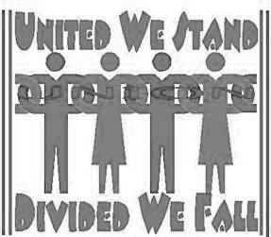

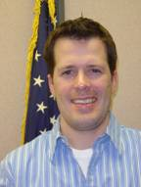

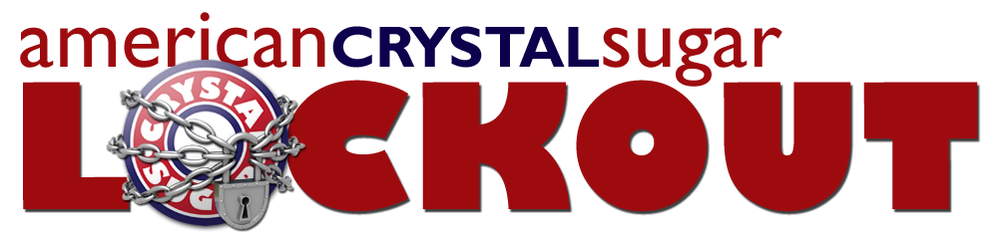

The Crystal Sugar Lockout is over a year old but nobody is celebrating. The workers of American Crystal continue to show solidarity in their efforts to remain a union. Because that is what the lockout really represents, union busting.
The lockout isn’t just hurting workers. It’s hurting Crystal Sugar’s bottom line. At a new website, www.crystalsugarfacts.com, three main facts are presented and examined.
First, production costs are skyrocketing. Production costs shot up $90 million, immediately after the lock out began- an increase of more than 23 percent. Cost of sales has increased 300 percent.
Second, shareholder payments lag behind the industry standard. Shareholders have typically been paid about the same per ton of sugar beets as shareholders in the Minn-Dak Cooperative. This year, Crystal is at $59 per ton, while Minn-Dak’s latest estimate for a payment is $74 per ton.
Third, executives are pocketing big raises. In the past three years, the top four officers saw their total compensation increase upwards of 34 percent with CEO Dave Berg seeing a 52% increase.
Yep, the boys at the top always stay flush.

More Lock-outs: Con-Ed of New York; N. Y. City Opera; NFL officials; Armstrong World Industries; Minnesota Orchestra

IBEW Wires for Nick Allende’s Walk across Niagara Falls

IBEW Local 1249 of Syracuse, NY provided the necessary manpower to string a seven ton cable 200 feet in the air over the misty, churning whitewater Niagara Falls for Nick Allende’s exciting feat.
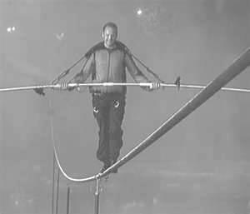
A core group of ten Local 1249 members spent a year in preparation. The task of setting up the cable actually takes about three days.
First, a chopper flies a smaller high-tension wire across and then workers on opposite sides secure the line. Next, the heavier cable gets spooled across the falls by IBEW members, in a somewhat similar way to stringing a utility line. The entire apparatus will be sutured to bedrock by heavy-duty bolts hundreds of yards from the brink of the falls.
The performer will be tethered to the sturdy cable by a lifeline to prevent what could otherwise be a fatal fall. In the unlikely event that he takes a spill, IBEW members will be in specialized retrieval devices to help.
IBEW’s Electric TV exclusive takes you behind the scenes. Watch it at www.electrictv.net

Nik Wallenda’s Incredible Walk Across
Niagara Falls on Friday, June 15, 2012

.



June is National Safety Month--NSC focuses on Drive Safely
Did you know hands-free devices offer no safety benefit when driving?
Did you know hands-free devices do not eliminate cognitive distraction?
Did you know drivers believe their own crash risk is lower than other drivers?

Did you know that about every 24 seconds there is a crash involving drivers using cell phones and texting?
The National Safety Council published a White Paper in April of 2012 entitled Understanding the Distracted Brain—why driving while using hands-free cell phones is risky behavior. Here is an interesting fact:
Why do drivers miss important driving cues?
Everything people see, hear, feel, taste, or think-all sensory information-must be committed to short-term memory before it can be acted on. Short-term memory can hold basic information for a few seconds. However, to get even very basic information into short-term memory, the brain goes through three stages to prioritize and process information. The first stage is called “encoding.”
Encoding is the step in which the brain selects what to pay attention to. Encoding is negatively affected by distractions and divided attention. During this first stage, the brain will “screen out” information as a way to deal with a distraction overload.
All human brains have limited capacity for attention. When there is too much information, the brain must decide what information is selected for encoding. Some decision processes are conscious and within a person’s control, while other decisions are unconscious so we’re not aware of them. Therefore, people do not have control over what information the brain processes and what information it filters out.
This 24 page White Paper is available for downloading at www.nsc.org. The NSC also offers an easier to understand series of short videos on YouTube explaining more about distracted driving. These are appropriate for family members.
Local 949 reminds its members to be aware of what rules their employers have in place and to follow them at all times.

DNT TXT & DRV



IBEW members in Castro Valley, California are working with BIM – Building Information Modeling. It’s the cutting edge blueprinting that helps build a building before building it. Check this out at www.ibewhourpower.com

A Great Union Rally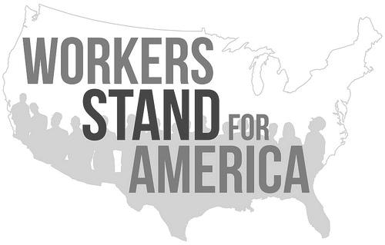

A great cross-section of workers, over 35,000, gathered in Philadelphia, PA on August 11, 2012. Their business? To call attention to how politics, society and the economy has been skewed beyond recognition—“geared almost entirely to the well-being of the richest while everyone else is left behind”.
IBEW President Edwin Hill, disgusted that the Democratic convention was being held in a right to work state with no union hotels or service workers, started planning for this last year and was prominent in organizing the rally. AFL-CIO President Richard Truman was one of the main speakers.
Philadelphia was chosen because it was where the first Bill of Rights was adopted and the words “Life, liberty, and the pursuit of happiness” changed the world.
Now it was time for a second Bill of Rights. A Bill of Rights based on the precept “True individual freedom cannot exist without economic security and independence.” This was President Franklin Roosevelt’s dream in 1944.
The Second Bill of Rights will be presented to delegates at the Republican and Democratic national conventions. The message will be delivered to public officials that “working people are tired of being ignored.”
This is not an accomplishment, but a start. A start to building a grassroots army to put this country back on the road to economic opportunity for all.
For a detailed description of the Second Bill of Rights, and to sign it and share it, go to www.workersstandforamerica.com. BE HEARD.

America’s Second
Bill of Rights

We the People want to strengthen our nation, as a beacon of equality, economic opportunity and freedom for all. We hold these rights to be essential to our vision of America and believe that the principles contained therein should guide our government, business leaders, organizations and individuals in our common goal of a just and fair society
The Right to Full Employment and a Living Wage
The Right to Full Participation in the Electoral Process
The Right to a Voice at Work
The Right to a Quality Education
The Right to a Secure Healthy Future

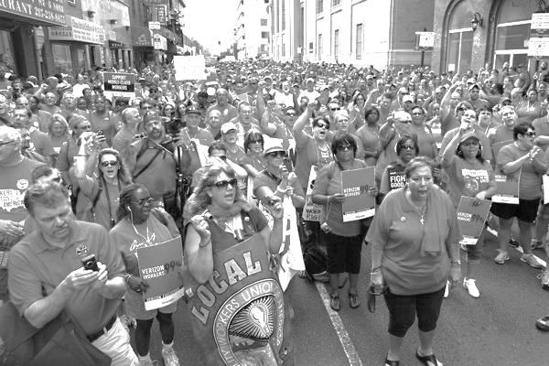

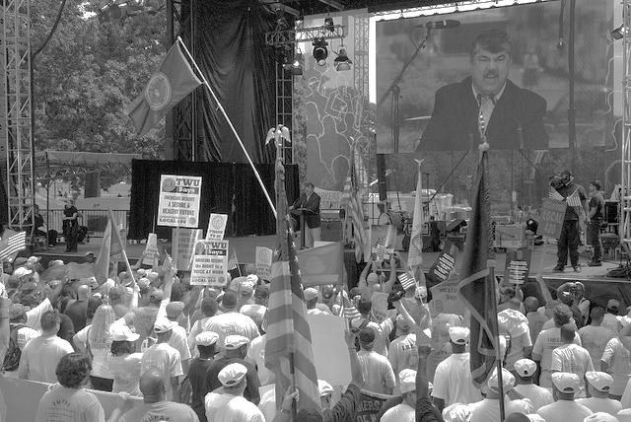
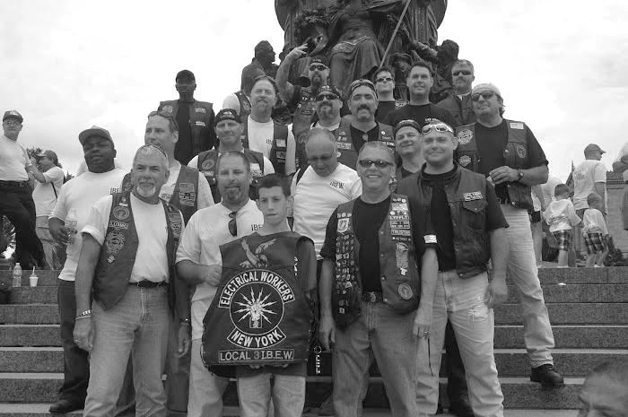

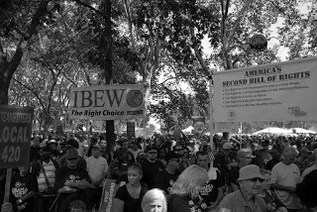


Union plus programs offer added value and union-made in the USA specials that hard-working union members like you won’t find anywhere else.
These rebates are only available while the funds last through the end of the year, so make sure you take advantage of these benefits NOW.

AT&T Smartphone Rebate up to $100 Upgrade to a smartphone & data plan with AT&T

—the only national Unionized wireless provider—
and you could receive a rebate up to $100.
See details on how to redeem this rebate at UnionPlus.org/ATTRebate.

Union-Made Auto Down Payment Rebate If you purchase a union-made vehicle through the Union Plus Auto Buying provider TrueCar, you’ll receive a 10% rebate for eligible car down payments up to $3,500. Check out UnionPlus.org/AutoRebates for the specifics.

Green Rebate You could receive $100 rebates for energy-efficient home improvements
and unionized HVAC installations. Visit UnionPlus.org/Green

THE 2013 UNION PLUS SCHOLARSHIP IS NOW AVAILABLE
AT
www.unionplus.org

IBEW
PHOTO CONTEST
DEADLINE:
OCT 31, 2012




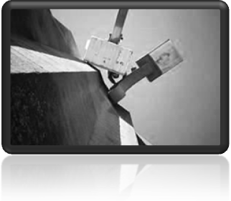
CHECK OUT RULES
AT www.ibew.org
HURRY! Your picture could be one of the winners!



STILL SERVING OUR COUNTRY

BRADLEY BERGEMAN/ALLIANT ENERGY

JAKE MATZ/INTEK

JASON PODRITZ/INTEK

Call the Hall

Weingarten Rights

If this discussion could in any way lead to my being disciplined or terminated or have any effect on my personal working conditions, I respectfully request that my union representative, officer, or steward be present at this meeting. Without union representation, I choose not to participate in this discussion.


Burnsville Office: 12908 Nicollet Ave S.
Burnsville, MN 55337-3598
Phone 1-952-890-8484 or
1-800-833-0949.
BARTZ, Rick, Business Rep. ext. 106
BREKKE, Sharon, Dues Processing ext. 103
INGALLS, Todd, Business Rep ext. 109
KAUFMAN, Mark, Business Rep. ext. 107
OAKES, RICK, Business Mgr.. ext. 104
O’CONNOR, Mike, Business Rep ext. 105
SOWER, Katie ext. 102
THOMFORDE, Gary, Business Rep. ext. 108
TIEDT, Elain, Office Mgr. ext. 101
E-mail: first name initial last name@ibewlocal949.org
Example: roakes@ibewlocal949.org

Address change? Call the Hall and the International or use websites. THANKS!
www.ibewlocal949.org
keeping in touch with
our members

Of interest:
Local 949 meeting is the third Saturday of each month at the Burnsville Office at 10:00 a.m.

Find your legislative representatives:
www.house.gov
www.senate.gov

Support Unionism
www.ibew.org
www.aflcio.org
www.shopunionmade.com

Comments welcomed at the Burnsville address or cy43@charter.net
---------------------------------------------------------------------------------------------------------------------

Check This Out:

Tired of your Big Bank? Is it putting you in a hole?
Check out the Bank of Labor-online financial products and services for people who care about labor. Founded in 1924 and owned by the International Brotherhood of Boilermakers, this is one of the last labor banks in the country. They do personal banking, business banking, business lending, treasury management services, trust services, retirement services, and more.
Bank of Labor gives you the power to bank with your values. Born of Integrity. Forged by Hard Work. Built to Last. Check it out at www.BankofLabor.com

SUPPORT YOUR UNION LOCAL
From our History:

The labor movement was the principal force that transformed misery and despair into hope and progress. Out of its bold struggles, economic and social reform gave birth to unemployment insurance, old age pensions, government relief for the destitute and above all, new wage levels that meant not mere survival but a tolerable life. The captains of industry did not lead this transformation.
Martin Luther King, Jr.

We have numerous economic problems, almost all of which can only be solved by cooperation between government, labor, and the private sector. This triumvirate is unbeatable.
Robert Anderson, former CEO (ARCO)

Note: No Fall issue of the newsletter was printed.

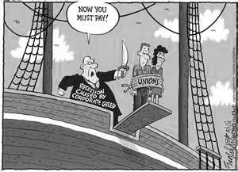

Non-Profit Org.
U.S. Postage Paid
Burnsville MN
Permit No. 202

IBEW Locals 949 and 343 guided installation of 21 new lights at the Soldiers Field Veterans Memorial in Rochester, MN. 949 members helping were Rob Castillo, Brad Gunderson (Steward), Dan Larson, Mark Larson (Unit Chair), Steve Laugen, Greg Sanders (Steward), and Lee Timmerman.




