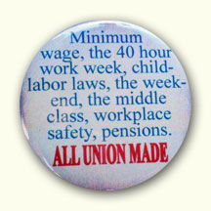

IBEW

LOCAL 949

NEWSLETTER
Spring 2013 Volume 13 Issue 1

OFFICIAL NOTICE OF IBEW LOCAL UNION 949
NOMINATIONS AND ELECTION OF
OFFICERS & EXECUTIVE BOARD MEMBERS–AT-LARGE

Pursuant to the IBEW Constitution, the Bylaws of IBEW Local 949 and the Labor Management and Reporting Disclosure Act (LMRDA) of 1959, this issue of the Local 949 Newsletter constitutes the official notice of the IBEW Local Union 949 elections for Business Manager/Financial Secretary, President, Vice President, Recording Secretary, Treasurer, and Five (5) Executive Board Members- at –Large.
The election of Local 949 Officers and Executive Board Members is coming up this year with nominations beginning in May. Nominations will be held as a special order of business at the regular May, 2013 meetings of the Bargaining Units. Nominations will be made only from the floor. Anyone nominated to more than one office must choose the office for which they will be a candidate. A candidate must either accept nomination at the meeting when nominated or have a letter in the hands of the Unit Recording Secretary prior to nomination.
Nominations for officers will proceed in the order of offices as listed in the IBEW Constitution whose term of office shall be three (3) years: President, Vice President, Recording Secretary, Treasurer, Business Manager/Financial Secretary, and Executive Board Members-at-Large (5).
In order to be nominated, a member must have a minimum of two years of continuous good standing in Local Union 949. “Good Standing” means that the member is current in his/her payment of dues and has been for the two years preceding the nominations.
Immediately after the nominations, the Unit Recorder shall forward a list of the names of the candidates, signed by the Unit Recorder and the Unit Chairman to the Election Judge. All nominations must be in the hands of the Election Judge at the Burnsville, Minnesota office by close of business on June 1, 2013.
Every candidate shall have the right once within thirty (30) days prior to the mailing of the ballots to inspect a list containing the names and last known addresses of all members of the Union. The membership list shall not be copied for the use of any candidate.
Local 949 shall comply with all reasonable requests of any bona fide candidate for the Local 949 office to distribute his or her campaign literature to the membership at the candidate’s expense. In handling all such requests, Local 949 shall comply with the IBEW Local Union Election Guide and with applicable Department of Labor regulations under the LMRDA of 1959.
The election shall be conducted by mail ballot. Ballots will be mailed to all members in good standing at their last known address on June 5, 2013 and they shall be counted beginning at 9:00 a.m. on June 26, 2013. Ballots received after the close of business on June 25, 2013 will not be opened or counted. Instruction on the use of the mail ballot will be enclosed with the ballot.
If you do not receive a ballot in the mail, contact the 949 Hall at 952-890-8484 or 800-833-0949 to request a duplicate ballot. Any such requests will be accepted up to five (5) days prior to the date of the election.
Prior to counting the ballots, the Election Judge and Tellers shall verify voter eligibility by comparing the return ballot envelope to the voter eligibility list. The election shall be decided by the highest vote count. The person receiving the highest vote for each office will be elected.
Candidates shall be entitled to have an observer present during the counting of the ballots. Observers may not interfere with the orderly procedure of the election. There shall be no campaigning or electioneering; no postings except for instructions shall be permitted.
All Officers shall be installed and begin their three year terms at the regular meeting of the Local Union on July 20, 2013.

VOTING INSTRUCTIONS
Eligible members will receive an official ballot in the mail with two envelopes. The small envelope shall have the words SECRET BALLOT
printed on it.

The larger envelope shall be pre-addressed to the election Judge and shall contain a space on the envelope where the member must place his/her name and address.

Upon receiving the ballot, members shall mark the ballot and enclose it in the smaller envelope marked SECRET BALLOT. This envelope shall be placed into the larger pre-addressed envelope and mailed to the Election Judge. Write-in votes are not permitted.

How do votes remain secret? The outer envelope with the member’s name on it is used to check against the eligibility list, just like in a national election. Then the inner envelope, marked SECRET BALLOT is removed and put in a pile with all the others. After all outer envelopes are opened and removed; the judges open the SECRET BALLOTS, and count the votes.

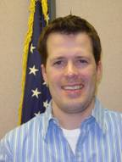
Any organizing leads are appreciated and should be sent to
The attention of
Business Rep Mike O’Connor
At moconnor@ibewlocal949.org

Best Wishes to the 2012 Retirees of Local 949

LINDA ANGLESE-Alliant, (Clinton, IA)
JAMES BOOK-Rochester PU, MN
SCOTT BRUMMER- OTP, (Fergus Falls, MN)
NEIL BRUNKOW-Lake City Municipal, MN
EUGENE CARLSON-OTP, (Milbank, S.D.)
DANIEL DOERING-Frontier, (Hector, MN)
MARK ERICKSON-Xcel Energy, (Winona, MN)
KEVIN FAHEY-CenterPoint Energy, (Burnsville, MN)
MARK FREDRICKSON-Xcel Energy, (Winona, MN)
GARY FULTON-Xcel Energy, (Red Wing, MN)
RONALD GORACKE-Alexandria Light & Power, MN
PATRICIA HARTSHORN-Lockheed Martin, Eagan, MN
MARY HARRIGAN- International Representative, Minneapolis, MN
JAMES HIMANGO-Rochester PU, MN
JEFFERY HOILAND-Tri-County REA, (Rushford, MN)
ROGER HOLMLUND-OTP, (Canby, MN)
JON HOMBACH-Hutchinson PU, MN
JAMES ILLG-Xcel Energy, (Red Wing, MN)
GERALD JOHANNSEN-Alliant, (Albert Lea, MN)
CURTIS JOHNSON-South Central, St James, MN
DONALD JOHNSON-Xcel Energy, (Red Wing, MN)
JOY KNUTSEN-Alliant, (Clinton, IA)
MARGARET KOSAR-Lockheed Martin, (St. Paul, MN)
STANLEY LANGOWSKI-Xcel Energy (Winona, MN)
JEFFERY MIDDENDORF-Alliant, (Lansing, IA)
MARK MILLER-Frontier, (Hector, MN)
MICHAEL MINKLER-CenterPoint Energy, (Coons Rapid, MN)
MICHAEL MOORE-Xcel Energy, (Red Wing, MN)
HARRYJOHN NIEBUHR-Hickory Tech, (Mankato, MN)
WAYNE OLSON-CenterPoint Energy, (Coon Rapids, MN)
GENE PEDERSON-Freeborn-Mower, Albert Lea, MN
WALLACE PERRON-CenterPoint Energy, (Mankato, MN)
MARK RASMUSSEN-Alliant, (Albert Lea, MN)
LAWRENCE REITH-Alliant, (Fulda, MN)
WYLIE RINDELS-Rochester PU, MN
JOE ROTHER-Dakota Electric, (Farmington, MN)
TODD SCHULER-Xcel Energy (Montevideo, MN)
CLEON SEEDORF-Alliant, ( Decorah, IA)
DENNIS SEGAR-Hickory Tech, (Mankato, MN)
CARL SKIME-City of Kasson, MN
MICHAEL SLUSS-CenterPoint Energy, (Brainerd, MN)
RICHARD SWING-CenterPoint Energy, (Mankato, MN)
THOMAS WERNER-OTP, (Milbank, S.D.)
CHARLES WIESE-Xcel Energy, (Sioux Falls, S.D.)
JAMES WURST-Xcel Energy, (Red Wing, MN)
ROBERT ZORN-Xcel Energy, (Red Wing, MN

Did you know?
You can get your IBEW newspaper, Electrical Worker, delivered each month via e-mail. It’s convenient and helps cut down on paper waste.
Go to www.ilbew.org and sign up today!

Welcome to 949!

Todd Ingalls is the newest Business Representative for Local 949. Ingalls comes from Hickory Tech in Mankato, MN. Hickory Tech is a communications provider with about 500 employees in Minnesota, North Dakota, and Iowa.
Todd was employed for eleven years as an installation and repair technician. He became a union steward in 2006 and has served as chairman since 2009.A graduate of South Dakota State University, he and his wife live in North Mankato, MN. In their spare time, they enjoy riding motorcycles and tending to their dog, Harley.
Ingalls will be the representative for Crosslake Telephone, Frontier Communications, International Falls, Cannon Falls, Hector, Warren, McGregor, Mound, Chisago/Lindstrom, Milaca, Two Harbors, Hickory Tech, Intek Plastics, and North Dakota Telephone.

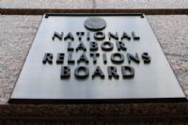

Trouble at the NLRB

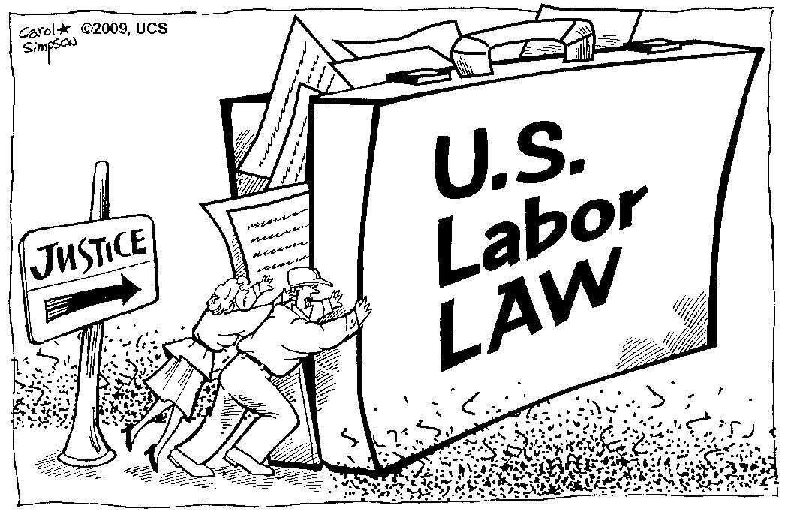In a move with extremely significant implications, the U.S. Court of Appeals for the D.C. Circuit held that President Obama’s three recess appointments to the National Labor Relations Board in January of 2012 were unconstitutional. If this is proven to be true, the Board was legitimately comprised of only two members, and any decisions that were issued during that time will be vacated.
Because President Obama’s nominations had been blocked at every turn, he did what many past presidents have done, and temporarily appointed three members to the NLRB in January of 2012.
Now, those appointments have been challenged. First, the D.C. court held that a recess appointment must be made during intersession recesses of the Senate. The Board appointments were not made during an intersession recess because they were made on January 4, 2012, which was one day after the Senate began a new session. Second, the court concluded that the Constitution permits the President to make a recess appointment only when the vacancy arises during the recesses.
“This ruling by the D.C. circuit court was way outside of mainstream thought and practice on presidential recess appointments,” said Aaron Albright, a spokesman for the House Education and the Workforce Committee.
The elimination of intersession appointments would have been particularly frustrating for George W. Bush, who made an estimated 141 such appointments, compared with Obama’s 26. Under President Regan, 232 appointments would have been unconstitutional.
Unless the D.C. Circuit reverses itself or is overturned by the Supreme Court, all of the NLRB’s recent actions are in jeopardy. The business lobby has already begun using the appeals court ruling to challenge court decisions favorable to unions.
NLRB chairman Mark Gaston Pearce has announced that the Board will continue issuing decisions and orders notwithstanding the D.C. Circuit’s decision.

Trimming trees around energized lines sounds like a bad thing to be doing, but the tree trimmers of Local 17 in Detroit, MI. don’t think much about it.
Learn what it takes to be an IBEW tree trimmer. Check this out at www.ibewhourpower.com

Solis Resigns

Secretary of Labor Hilda L. Solis resigned from her post on January 22, 2013. Solis, a former congresswoman from California, acknowledged that “leaving the department is one of the most difficult decisions I have ever made. She went on to say that, “as the daughter of parents who worked in factories, paid their union dues and achieve their goal of a middle class life, and as the first Latina to head a major federal agency, it has been an incredible honor to serve”.
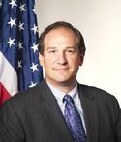Until President Obama appoints a new Labor Secretary, Seth D. Harris is Acting Secretary of Labor.
Harris is a graduate of the School of Industrial and Labor Relations at Cornell University and the New York University School of Law. He served seven years at the Department of Labor during the Clinton Administration and has been Deputy Secretary of Labor since 2009.

Available Scholarships
Forms available from unit chairman or the Hall

CHARLES R. BRETT IBEW MINNESOTA STATE COUNCIL SCHOLARSHIP
(Children of members)
IBEW FOUNDERS SCHOLARSHIP (members)
MARTIN DUFFY ADULT LEARNER SCHOLARSHIP (members)
MINNESOTA AFL-CIO SCHOLARSHIPS (members and dependents)
MINNESOTA LABOR LEADERSHIP GRANTS (members)
MINNESOTA BUILDING TRADES FEDERAL CREDIT UNION (children)
UNION PLUS SCHOLARSHIPS (members, retired members, dependents)
NORTH DAKOTA AFL-CIO LABOR LEADERS SCHOLARSHIP (members)

From March 5th To May 15th Enter To Win A Free Disney Dream Vacation!
Union members work hard. Union families deserve a chance to play hard! That’s why Union Plus is offering union members the chance to win a Disney Dream Vacation by signing up to receive emails with union-member-only savings and special offers.
The vacation package includes round-trip airfare for four, four nights hotel, five days car rental, plus four Disney World 4-Day Park Hopper with Water Park tickets (two adult, two children).
Remember, a Disney vacation isn’t only fun-it’s union-friendly. Disney World employees are represented by unions including UNITE HERE, The International Brotherhood of Teamsters, the United Food and Commercial Workers Union, the Transportation Communications Union, and the International Alliance of Theatrical State Employees.
For full contest details and to enter to win a Disney Dream Vacation, visit UnionPlus.org/Contest by May 15, 2013.
STILL SERVING OUR COUNTRY

BRADLEY BERGEMAN/ALLIANT ENERGY

JAKE MATZ/INTEK

JASON PODRITZ/INTEK

Locked-out American Crystal Sugars workers of North Dakota caught a bit of hope when The North Dakota Supreme Court reversed an action denying the employees unemployment benefits.
The 3-2 decision, following months of deliberation on arguments presented Sept 18, 2012 could mean a payout of about $4 million.
Unemployment benefits in North Dakota are up to 50 percent of wages for up to 26 weeks.
However, because the North Dakota Legislature is in session, lawmakers could pass a law negating the decision.
At the same time, State senator Phil Murphy of Portland, ND has introduced a bill that would extend unemployment benefits to workers locked out of their jobs.
And in Minnesota, Representative Joe Atkins from Inver Grover Heights is planning two lock-out provisions in bills still being written.
Union members can show their support to the locked-out workers by contacting these senators and encouraging their efforts. You can email them at: Phil Murphy at pmmurphy@nd.gov and Joe Adkins at rep.joe.atkins@house.mn.
Union members can also show their support by honoring the AFL-CIO boycott of American Crystal Sugar products, including Target’s house brand “Market Pantry.”

LOCK-OUT! COMING TO A COMPANY NEAR YOU!

In October of 2012, IBEW’s 949 (MN) and 204 (IA) voted to accept a contract from Alliant/IPL, which, among other things, takes away all right to bargain over the health care issue. IPL threatened to lock out these utility workers if they didn’t accept concessions. The company openly and aggressively recruited and trained scabs to take their jobs.

949 Members Assist in SuperStorm Sandy

LOCAL 949 members from Otter Tail Power, Alliant, Xcel, Hutchinson and Owatonna
traveled to the ravaged east coast to assist with disaster recovery in the wake of SuperStorm Sandy.
The crews faced many difficulties--streets littered with debris-- getting supplies-- battling extreme weather conditions--and poor accommodations (sleeping in tents and trucks!), not to mention trying to communicate with all the different entities involved.
SuperStorm Sandy caused more outages than Hurricanes Katrina, Andrew, and Isaac-more than any storm in our nation’s history.
It took the efforts of over 60,000 electrical workers working together to get the lights back on after this disaster.

The IBEW is using its newly created Unity Fund to help more than 70,000 members living in the disaster zone. To make a contribution, go to www.ibew.org/unityfund.

Call the Hall

Weingarten Rights

If this discussion could in any way lead to my being disciplined or terminated or have any effect on my personal working conditions, I respectfully request that my union representative, officer, or steward be present at this meeting. Without union representation, I choose not to participate in this discussion.

Burnsville Office: 12908 Nicollet Ave S.
Burnsville, MN 55337-3598
Phone 1-952-890-8484 or
1-800-833-0949.
BARTZ, Rick, Business Rep. ext. 106
BREKKE, Sharon, Dues Processing ext. 103
KAUFMAN, Mark, Business Rep. ext. 107
INGALLS, Todd, Business Rep.. ext. 109
OAKES, RICK, Business Mgr.. ext. 104
O’CONNOR, Mike, Business Rep ext. 105
SOWER, Katie, Administrative Assistant ext. 102
THOMFORDE, Gary, Business Rep. ext. 108
TIEDT, Elain, Office Mgr. ext. 101
E-mail: first name initial last name@ibewlocal949.org
Example: roakes@ibewlocal949.org
Address change? Call the Hall and the International or use websites. THANKS!
www.ibewlocal949.org
keeping in touch with
our members

Of interest:
Local 949 meeting is the third Saturday of each month at the Burnsville Office at 10:00 a.m.

Find your legislative representatives:
www.house.gov
www.senate.gov

Support Unionism
www.ibew.org
www.aflcio.org
www.shopunionmade.com

Comments welcomed at the Burnsville address or cy43@charter.net
---------------------------------------------------------------------------------------------------------------------

Check This Out:

Emerge Wisconsin is a premier training program for Democratic women to help them successfully run for political office. It is part of a national network currently working in ten states. If you are interested in becoming a political contender or would like to see the program operating in your state, check it out at www.emergewi.org.
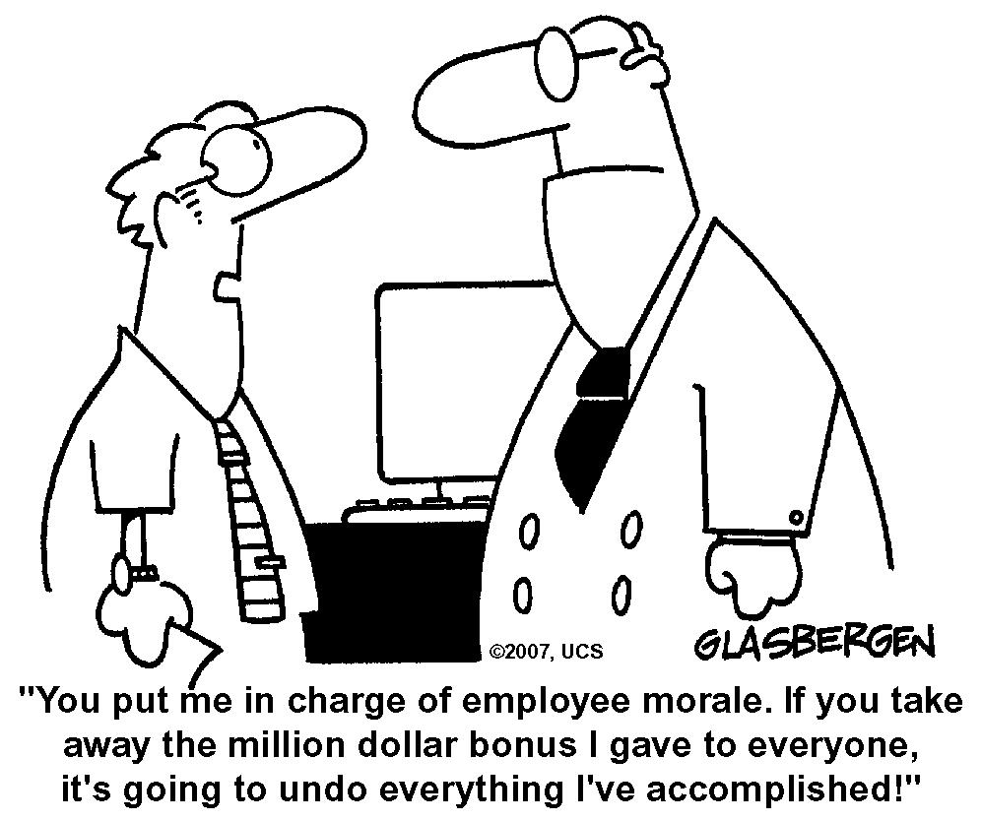

From our History:

It is a sad commentary upon our form of government when every decision of the Supreme Court seems designed to fatten Capital and destroy Labor.
John L. Lewis, 1993
It is one of our proudest boasts that the American working class has, generally speaking, the highest standard of living of any working class in the world. How did our workingmen achieve this position? Only through struggle, intense struggle against bitter opposition and especially through the struggle of organized labor.
Rockwell Kent, 1950

Note: No Fall issue of the newsletter was printed.

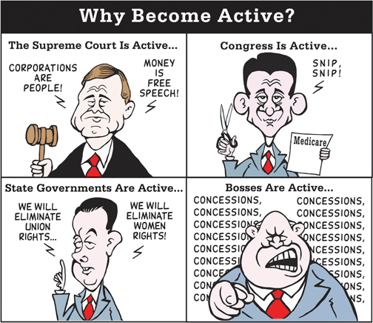
Non-Profit Org.
U.S. Postage Paid
Burnsville MN
Permit No. 202

Cold is a relative thing…

65°
Arizonans turn on the heat.
People in Minnesota plant gardens.
60°
Californians shiver uncontrollably.
People in Minnesota sunbathe.
50°
Italian cars won’t start
People in Minnesota drive with windows down.
40°
Georgians don coats, thermal underwear, gloves and wool hats.
People in Minnesota throw on a flannel shirt.
35°
New York landlords finally turn up the heat.
People in Minnesota have the last cookout before it gets cold.
20°
People in Miami all die.
Minnesotans close the window.
0°
Californians fly away to Mexico
People in Minnesota get out their winter coats
-10°
Hollywood disintegrates
The Girl Scouts in Minnesota are selling cookies door to door.
-20°
Washington D.C. runs out of hot air. (Ya think? Nah!!)
People in Minnesota let their dogs sleep indoors.
-30°
Santa Claus abandons the North Pole.
School and busses are two hours late in Minnesota!

